Practice Queries 1

- Find Second Highest Salary from Employee table using subquery

select max(Salary) from Employee where Salary < (select max(Salary) from Employee);

- Find Second Highest Salary from Employee table using "not" any where in the query

select * from Employee e1 where 2 = (select count(distinct e2.salary) from Employee e2
where e1.salary <= e2.salary);

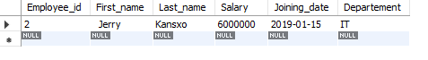
- Find Second Highest Salary from Employee table using inline table

select * from (select max(salary) from Employee where salary not in (select max(Salary) from Employee)) as inline_sql;
select * from(select max(Salary) from Employee where Salary < (select max(Salary) from Employee)) as sec_high;

- Find Second Highest Salary from Employee table using rank window function

select * from
(select Employee_id, Departement, Salary, rank() over (order by Salary desc) as "rnk" from Employee) e where e.rnk = 2;

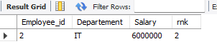
- Find Second Highest Salary from Employee table using limit

select salary From Employee order by Salary desc limit 1,1;
- Find Second Highest Salary from Employee table using "<>" any where in the query

select max(salary) from Employee where Salary <> (select max(salary) from Employee);
- Find Second Highest Salary from Employee table using "max() function and subquery" anywhere in the query

select max(Salary) from Employee where Salary < (select max(Salary) from Employee);
- Find duplicate employees in reward table

select Employee_ref_id from reward group by Employee_ref_id having count(Employee_ref_id) >1;

- Rank each salary using rank function

select Employee_id, Departement, Salary, rank() over(order by Salary desc) as rank_order from Employee;
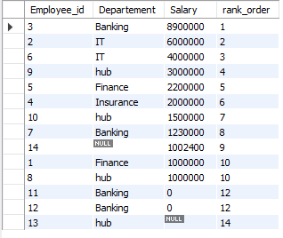

- Rank each salary using dense rank function

select Employee_id, Departement, salary, dense_rank() over(order by Salary desc) as drank_or from Employee;

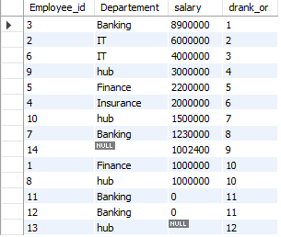

- Rank each salary "with out" using rank functions

select * from ( select Salary, row_number() over (order by salary desc) as row_num from Employee )e;

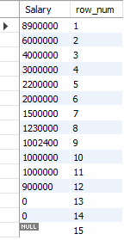

- . Find Second Highest Salary from Employee table using "!=" any where in the query

select max(salary) from Employee where Salary != (select max(Salary) from Employee);

- Find Second Highest Salary from Employee table using "left join and self join" anywhere in the query

Select e1.Employee_id, e1.Salary from Employee e1 inner join Employee e2 on e1.Salary = e2.Salary order by Salary desc limit 1,1;

- Find Second Highest Salary from Employee table using Row_number() function

select * from ( select Salary, row_number() over (order by salary desc) as row_num from Employee )e where e.row_num = 2;
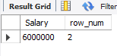
- Find Second Highest Salary from Employee table using "Row_number() function" and pass blank inside “over()”

select * from (select Salary, row_number() over() as sec_sal from Employee order by Salary desc)r where r.sec_sal= 2;


